Assignment – 4.2

1. x <- c(‘data.science.in.R’, ‘machine.learning.in.R’)

Perform the below string Operation:

• Replace the period character "." within each string with another character i.e. "-" minus sign.

Solution:

>x<-c('data.science.in.R','machine.learning.in.R')

> x

[1] "data.science.in.R" "machine.learning.in.R"

> gsub('\\.', '-', x)

[1] "data-science-in-R" "machine-learning-in-R"

>

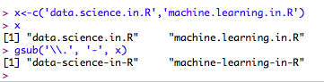

2. x <- c('data.science.in.R','machine.learning.in.R')

Perform the below String Operation:

• Append again with “-“ minus sign character at the start of the each string and finally concatenate all the string within the vector to form a final single string and assigning it the object.

Solution:

> a=paste0('-',b=c("abc","cde"), collapse='')

> a

[1] "-abc-cde"

